Week-3 Hands-on Spring REST using Spring Boot 3:
- Create a Spring Web Project using Maven:

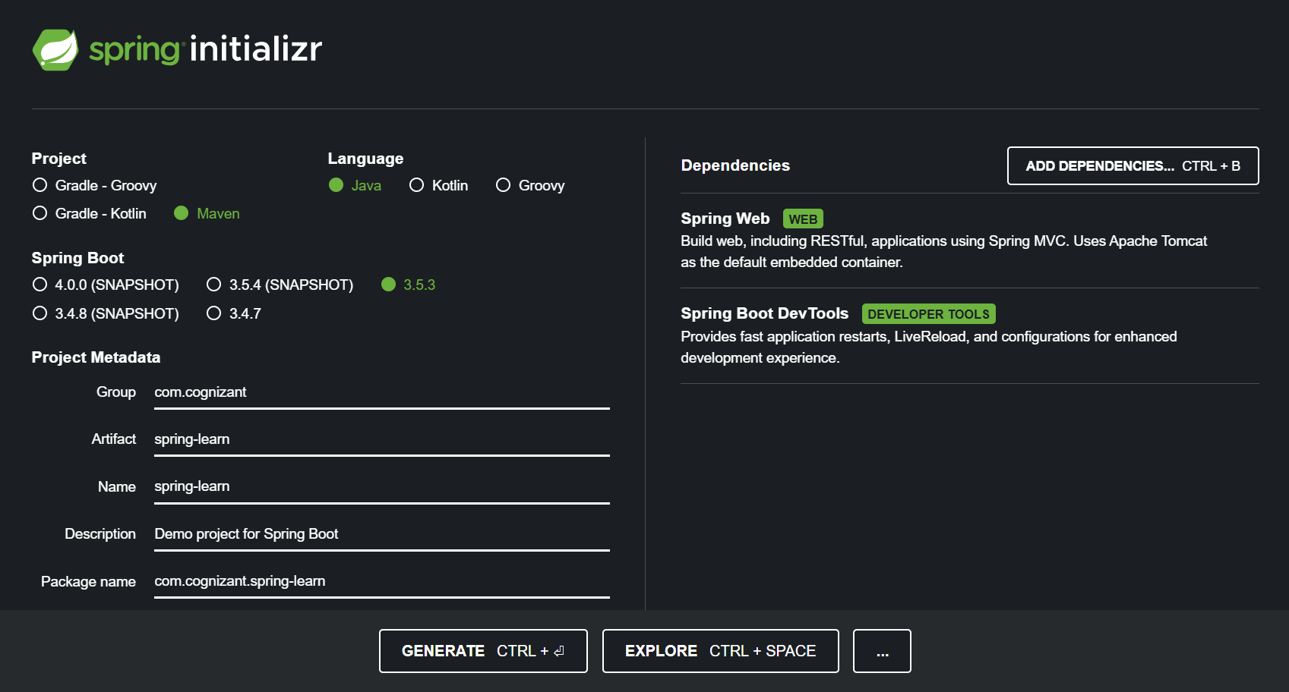

- Spring Core – Load Country from Spring Configuration XML:

· Configuring Spring XML configuration named country.xml.
· Creating a bean tag in spring configuration for country and set the property and values
File name: country.xml
<?xml version="1.0" encoding="UTF-8"?>
<beans xmlns="http://www.springframework.org/schema/beans"
xmlns:xsi="http://www.w3.org/2001/XMLSchema-instance"
xsi:schemaLocation="http://www.springframework.org/schema/beans
http://www.springframework.org/schema/beans/spring-beans.xsd">
<bean id="country" class="com.cognizant.spring_learn.Country">
<property name="code" value="IN"/>
<property name="name" value="India"/>
</bean>
</beans>
Creating Country class with following aspects:
- Instance variables for code and name
- Implement empty parameter constructor with inclusion of debug log within the constructor with log message as “Inside Country Constructor.”
- Generate getters and setters with inclusion of debug with relevant message within each setter and getter method.
- Generate toString() method , method displayCountry() in SpringLearnApplication.java, which will read the country bean from spring configuration file and display the country
File name: Country.java
package com.cognizant.spring_learn;
import org.slf4j.Logger;
import org.slf4j.LoggerFactory;
public class Country {
private static final Logger LOGGER = LoggerFactory.getLogger(Country.class);
private String code;
private String name;
public Country() {
LOGGER.debug("Inside Country Constructor.");
}
public String getCode() {
LOGGER.debug("Getting code");
return code;
}
public void setCode(String code) {
LOGGER.debug("Setting code");
this.code = code;
}
public String getName() {
LOGGER.debug("Getting name");
return name;
}
public void setName(String name) {
LOGGER.debug("Setting name");
this.name = name;
}
@Override
public String toString() {
return "Country [code=" + code + ", name=" + name + "]";
}
}
- Invoke displayCountry() method in main() method of SpringLearnApplication.java.
- Execute main() method and check the logs to find out which constructors and methods were invoked
File name: SpringLearnApplication.java
package com.cognizant.spring_learn;
import org.slf4j.Logger;
import org.slf4j.LoggerFactory;
import org.springframework.context.ApplicationContext;
import org.springframework.context.support.ClassPathXmlApplicationContext;
public class SpringLearnApplication {
private static final Logger LOGGER = LoggerFactory.getLogger(SpringLearnApplication.class);
public static void displayCountry() {
ApplicationContext context = new ClassPathXmlApplicationContext("country.xml");
Country country = context.getBean("country", Country.class);
LOGGER.debug("Country : {}", country.toString());
}
public static void main(String[] args) {
displayCountry();
}
}
OUTPUT:
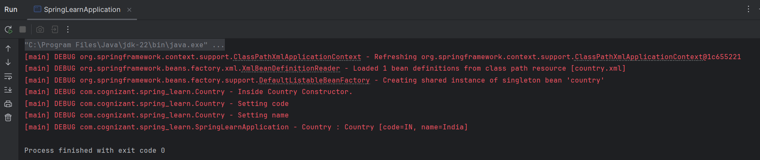

3. Hello World RESTful Web Service:
- Created the controller class for implementing the rest service for returning a text “Hello World”

File name: HelloController.java
package com.cognizant.spring_learn.Contoller;

import org.slf4j.Logger;
import org.slf4j.LoggerFactory;
import org.springframework.web.bind.annotation.GetMapping;
import org.springframework.web.bind.annotation.RestController;

@RestController
public class HelloController {

private static final Logger LOGGER = LoggerFactory.getLogger(HelloController.class);

@GetMapping("/hello")
public String sayHello() {
LOGGER.debug("START: sayHello()");
String response = "Hello World!!";
LOGGER.debug("END: sayHello()");
return response;
}
}

File name: SpringLearnApplication.java
package com.cognizant.spring_learn;

import org.springframework.boot.SpringApplication;
import org.springframework.boot.autoconfigure.SpringBootApplication;

@SpringBootApplication
public class SpringLearnApplication {
public static void main(String[] args) {
SpringApplication.run(SpringLearnApplication.class, args);
}
}
OUTPUT:
Testing the Api service with post man

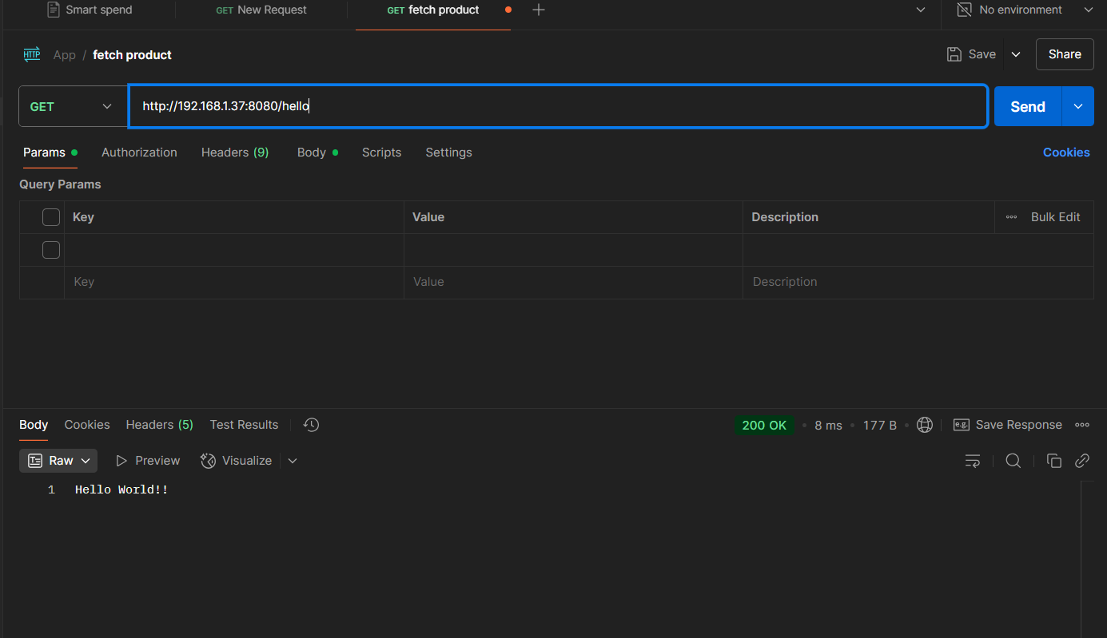

Testing the Api service in chrome browser
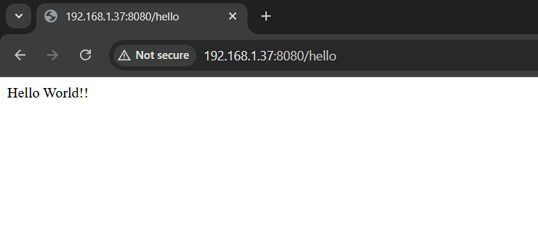
- REST - Country Web Service:

- Created controller class for country to handle the service

File name: CountryController.java

package com.cognizant.spring_learn.Contoller;
import com.cognizant.spring_learn.Country;
import org.slf4j.Logger;
import org.slf4j.LoggerFactory;
import org.springframework.context.ApplicationContext;
import org.springframework.context.support.ClassPathXmlApplicationContext;
import org.springframework.web.bind.annotation.RequestMapping;
import org.springframework.web.bind.annotation.RestController;

@RestController
public class CountryController {

private static final Logger LOGGER = LoggerFactory.getLogger(CountryController.class);

@RequestMapping("/country")
public Country getCountryIndia() {
LOGGER.debug("START getCountryIndia()");

ApplicationContext context = new ClassPathXmlApplicationContext("country.xml");
Country country = (Country) context.getBean("country");

LOGGER.debug("Country : {}", country.toString());
LOGGER.debug("END getCountryIndia()");
return country;
}
}

OUTPUT:
Testing the country web service using postman
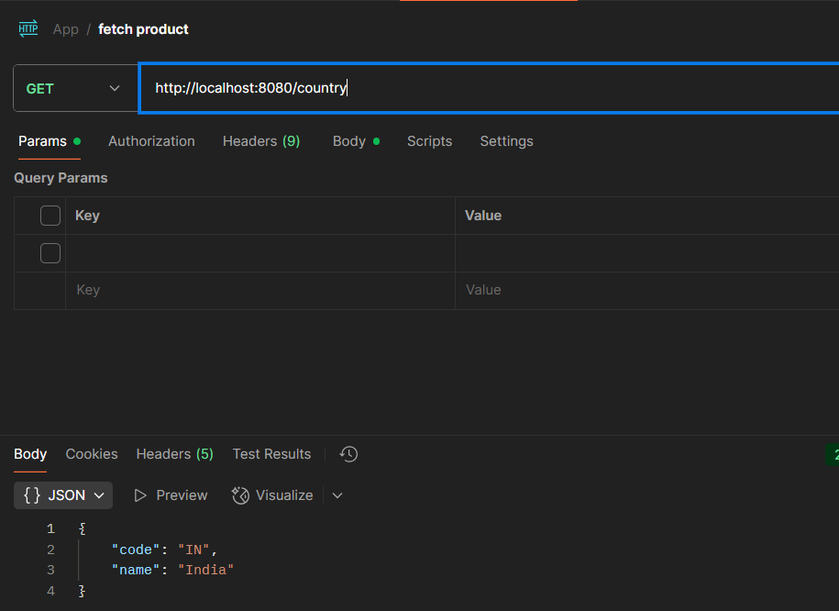

- REST - Get country based on country code:

- Created a method inside the controller class with the @GetMapping annotation

File name: CountryController.java

package com.cognizant.spring_learn.Contoller;
import com.cognizant.spring_learn.Country;
import com.cognizant.spring_learn.Service.CountryService;
import org.slf4j.Logger;
import org.slf4j.LoggerFactory;
import org.springframework.beans.factory.annotation.Autowired;
import org.springframework.context.ApplicationContext;
import org.springframework.context.support.ClassPathXmlApplicationContext;
import org.springframework.web.bind.annotation.GetMapping;
import org.springframework.web.bind.annotation.PathVariable;
import org.springframework.web.bind.annotation.RequestMapping;
import org.springframework.web.bind.annotation.RestController;

@RestController
public class CountryController {
@Autowired
private CountryService countryService;

private static final Logger LOGGER = LoggerFactory.getLogger(CountryController.class);

@GetMapping("/countries/{code}")
public Country getCountry(@PathVariable String code) {
LOGGER.info("START getCountry - code: {}", code);
Country country = countryService.getCountry(code);
LOGGER.info("END getCountry");
return country;
}
@RequestMapping("/country")
public Country getCountryIndia() {
LOGGER.debug("START getCountryIndia()");

ApplicationContext context = new ClassPathXmlApplicationContext("country.xml");
Country country = (Country) context.getBean("country");

LOGGER.debug("Country : {}", country.toString());
LOGGER.debug("END getCountryIndia()");
return country;
}
}

- Created a service class for handling the service. The getCountry() service method gets the country.xml and iterate the countries list

File name: CountryService.java

package com.cognizant.spring_learn.Service;
import com.cognizant.spring_learn.Country;
import org.slf4j.Logger;
import org.slf4j.LoggerFactory;
import org.springframework.context.ApplicationContext;
import org.springframework.context.support.ClassPathXmlApplicationContext;
import org.springframework.stereotype.Service;

import java.util.List;

@Service
public class CountryService {

private static final Logger LOGGER = LoggerFactory.getLogger(CountryService.class);

public Country getCountry(String code) {
LOGGER.info("START getCountry with code: {}", code);
ApplicationContext context = new ClassPathXmlApplicationContext("country.xml");

List<Country> countryList = context.getBean("countryList", List.class);

return countryList.stream()
.filter(c -> c.getCode().equalsIgnoreCase(code))
.findFirst()
.orElse(null);
}
}

OUTPUT:

Tested the get country by code service using postman
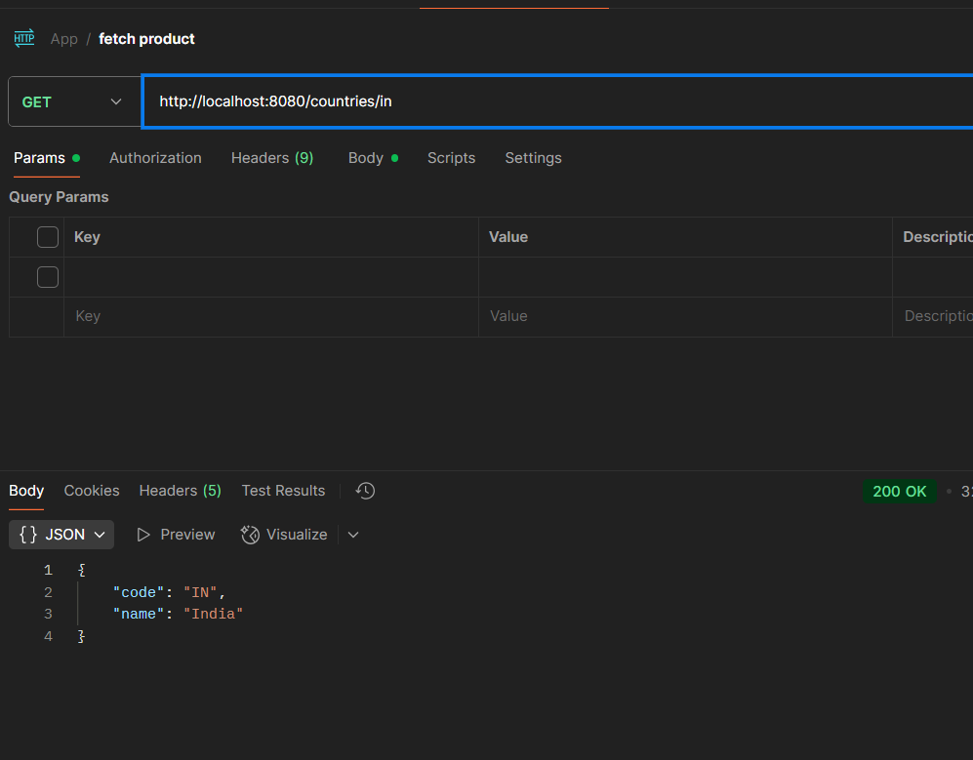

- Create authentication service that returns JWT:

- Creating the controller class for Authentication

File name: AuthenticationController.java

package com.cognizant.spring_learn.Contoller;

import com.cognizant.spring_learn.model.AuthenticationResponse;
import com.cognizant.spring_learn.util.JwtUtil;
import org.springframework.beans.factory.annotation.Autowired;
import org.springframework.security.authentication.AuthenticationManager;
import org.springframework.security.authentication.UsernamePasswordAuthenticationToken;
import org.springframework.security.core.AuthenticationException;
import org.springframework.web.bind.annotation.*;

@RestController
public class AuthenticationController {

@Autowired
private AuthenticationManager authenticationManager;

@Autowired
private JwtUtil jwtUtil;

@RequestMapping(value = "/authenticate", method = RequestMethod.GET)
public AuthenticationResponse generateToken(@RequestHeader("Authorization") String authHeader) {
try {
String base64Credentials = authHeader.substring("Basic ".length());
byte[] decodedBytes = java.util.Base64.getDecoder().decode(base64Credentials);
String decodedCredentials = new String(decodedBytes);
String[] parts = decodedCredentials.split(":");
String username = parts[0];
String password = parts[1];

authenticationManager.authenticate(new UsernamePasswordAuthenticationToken(username, password));
String token = jwtUtil.generateToken(username);
return new AuthenticationResponse(token);

} catch (AuthenticationException e) {
throw new RuntimeException("Invalid Credentials");
}
}
}

File name: SecurityConfig.java
package com.cognizant.spring_learn.security;

import org.springframework.context.annotation.Bean;
import org.springframework.context.annotation.Configuration;
import org.springframework.security.authentication.AuthenticationManager;
import org.springframework.security.config.annotation.authentication.builders.AuthenticationManagerBuilder;
import org.springframework.security.config.annotation.web.configuration.EnableWebSecurity;
import org.springframework.security.config.annotation.web.builders.HttpSecurity;
import org.springframework.security.crypto.password.NoOpPasswordEncoder;
import org.springframework.security.provisioning.InMemoryUserDetailsManager;
import org.springframework.security.core.userdetails.User;
import org.springframework.security.core.userdetails.UserDetailsService;
import org.springframework.security.web.SecurityFilterChain;

@Configuration
@EnableWebSecurity
public class SecurityConfig {

@Bean
public UserDetailsService userDetailsService() {
return new InMemoryUserDetailsManager(
User.withUsername("user")
.password("pwd")
.roles("USER")
.build()
);
}

@Bean
public AuthenticationManager authenticationManager(HttpSecurity http, UserDetailsService userDetailsService) throws Exception {
return http.getSharedObject(AuthenticationManagerBuilder.class)
.userDetailsService(userDetailsService)
.passwordEncoder(passwordEncoder())
.and()
.build();
}

@Bean
public SecurityFilterChain filterChain(HttpSecurity http) throws Exception {
http.csrf().disable()
.authorizeRequests().anyRequest().authenticated()
.and().httpBasic();
return http.build();
}

@SuppressWarnings("deprecation")
@Bean
public static NoOpPasswordEncoder passwordEncoder() {
return (NoOpPasswordEncoder) NoOpPasswordEncoder.getInstance();
}
}

- Generating token based on user retrieval
File name: JwtUtil.java

package com.cognizant.spring_learn.util;

import io.jsonwebtoken.Jwts;
import io.jsonwebtoken.SignatureAlgorithm;
import io.jsonwebtoken.security.Keys;
import org.springframework.stereotype.Component;

import java.nio.charset.StandardCharsets;
import java.security.Key;
import java.util.Date;

@Component
public class JwtUtil {

private final String SECRET_KEY = "karthikeyan-your-custom-secret-key-123456"; // Use min 256-bit key (32+ characters)

public String generateToken(String username) {
Key key = Keys.hmacShaKeyFor(SECRET_KEY.getBytes(StandardCharsets.UTF_8));

return Jwts.builder()
.setSubject(username)
.setIssuedAt(new Date(System.currentTimeMillis()))
.setExpiration(new Date(System.currentTimeMillis() + 1000 * 60 * 60 * 10)) // 10 hours
.signWith(key, SignatureAlgorithm.HS256)
.compact();
}
}

OUTPUT:

